# Exercise 1:

1. Build a phishing website classifier using Logistic Regression with “C” parameter = 100.
2. Use 70% of data as training data and the remaining 30% as test data.
3. Print count of misclassified samples in the test data prediction as well as the accuracy score of the model.

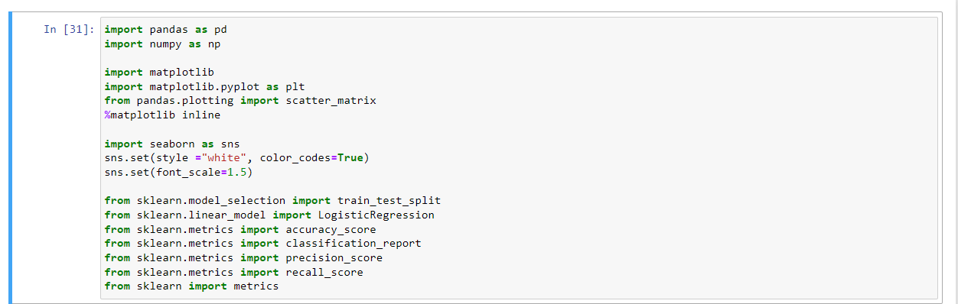 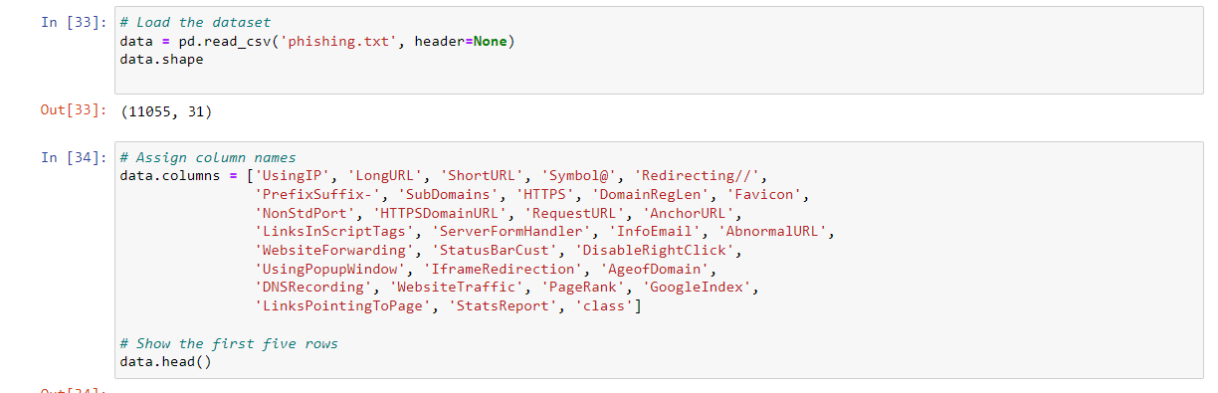

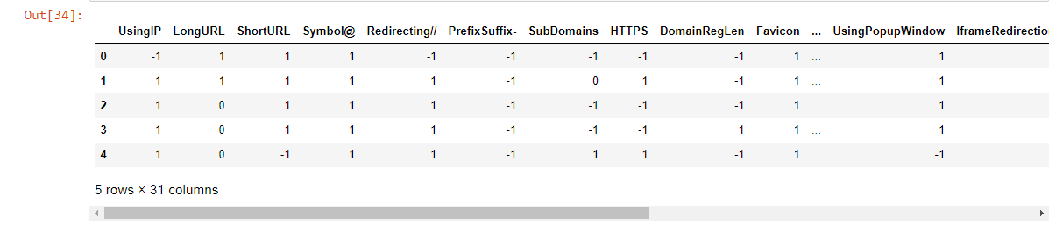

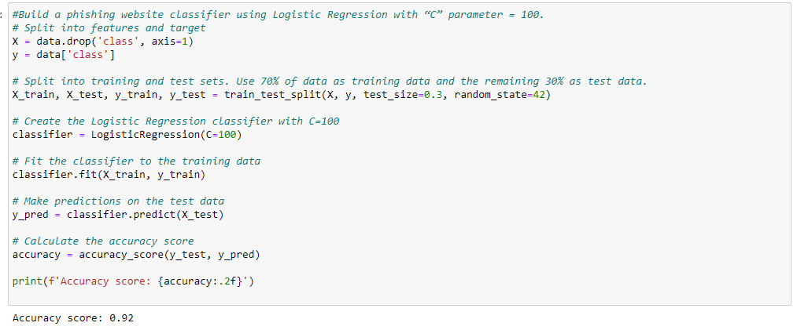

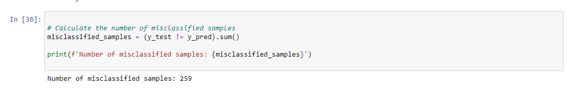

# Exercise 2:

* Train with only two input parameters - parameter Prefix_Suffix and 13 URL_of_Anchor.
* Check accuracy using the test data and compare the accuracy with the previous value.
* Plot the test samples along with the decision boundary when trained with index 5 and index 13 parameters.

